A000-MEX-Mezcala-Mask-Pre Classic-300-100 BCE

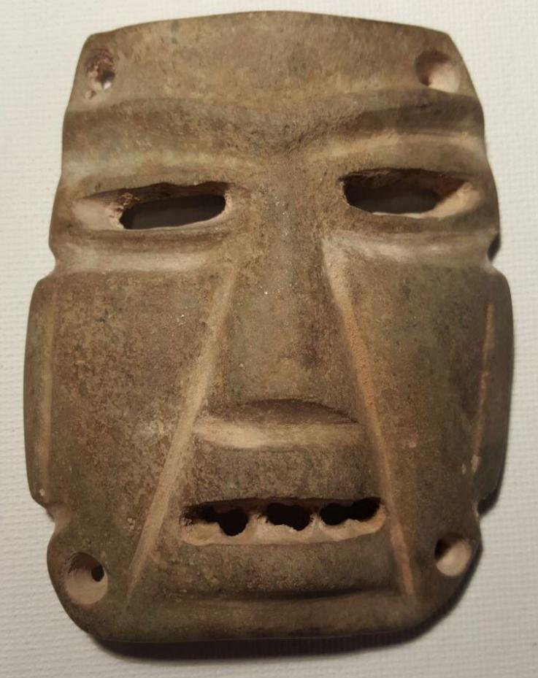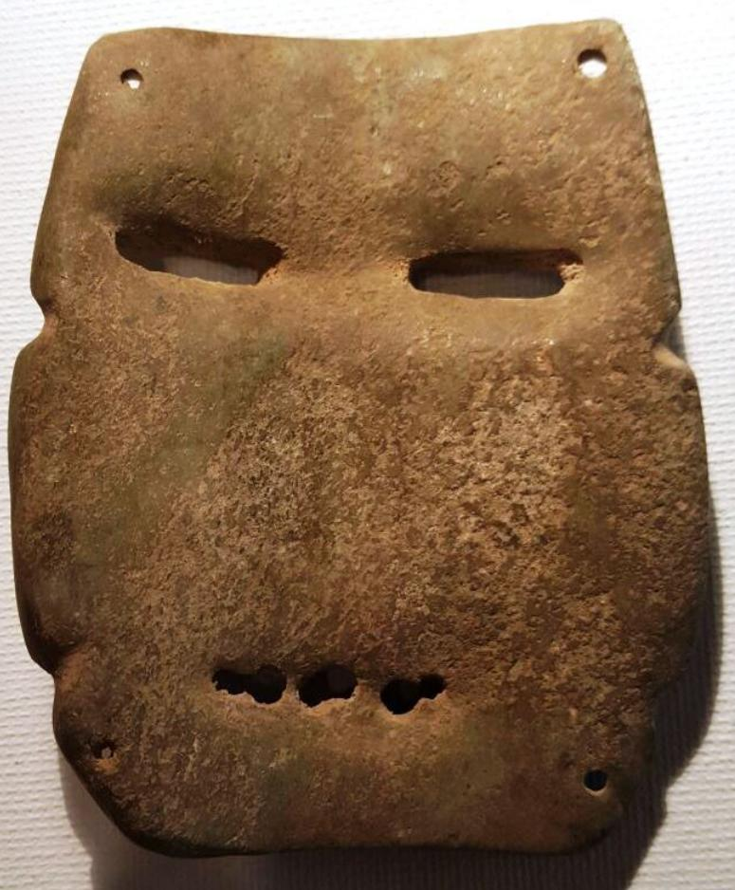

MEX-Mezcala-Head-Brown Basalt-300 BCE

Case No.: 14

**Accession No.**

**Formal Label:**

**Display Description:**

**LC Classification:**

**Date or Time Horizon:**

**Geographical Area:**

**Map:**

**GPS coordinates:**

**Cultural Affiliation:**

**Media:**

**Dimensions:**

**Weight:**

**Condition:**

**Provenance:**

**Discussion:**

**References:**

PRE COLUMBIAN MEZCALA STONE MASK   
  
THIS BEAUTIFUL PIECE IS ATTRIBUTED TO THE PRE-CLASSIC 300-100 B.C.   
  
DIMENSIONS: HEIGHT: 3 1/2" tall 3" wide   
  
From a collection that was formed in in the 1960's   
  
"100% AUTHENTIC OR YOUR MONEY BACK"

# Order details

## Sales order

Sold by [azpar75](http://myworld.ebay.com/azpar75) ( [817](http://feedback.ebay.com/ws/eBayISAPI.dll?ViewFeedback&userid=azpar75) )

### Delivery package 1 of 1

Estimated delivery Thursday, Apr 7, 2016 - Monday, Apr 11, 2016

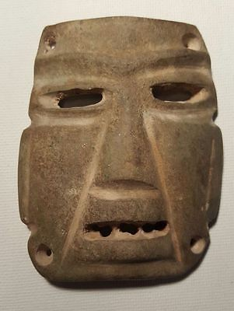

#### [PRE COLUMBIAN MEZCALA STONE MASK - !SALE NOT RESERVE!](http://www.ebay.com/itm/272186625098)

|  |  |
| --- | --- |
| Item price | $299.00 |
| Quantity | 1 |
| Item number | 272186625098 |
| Shipping service | USPS Priority Mail |

## Shipping address

Ralph J Coffman Jr

149 Atlantic Ave

Swampscott MA 01907-2427

United States

## Order total

|  |  |
| --- | --- |
| Subtotal | $299.00 |
| Shipping | $22.00 |

**Total**

$321.00

Order placed on

Friday, Apr 1, 2016

Payment method

PayPal

Payment date

Friday, Apr 1, 2016

|  |  |
| --- | --- |
| ORDER DATEMar 17, 2016 | ORDER TOTAL  US $278.00  + US $10.50  shipping  **Order mezcala head pendant Precolumbian Ancient,precolumbian mezcala head chontal ex. joe gerena collection** [View order details - ORDER DATE Mar 17, 2016](http://payments.ebay.com/ws/eBayISAPI.dll?ViewPaymentStatus&transId=1621351515017&itemid=271900274501&_trksid=p2057872.m2749.l2673)[Contact seller](http://contact.ebay.com/ws/eBayISAPI.dll?ShowSellerFAQ&requested=bibliovendor&iid=271900274501&redirect=0&_trksid=p2057872.m2749.l2652) - ORDER DATE Mar 17, 2016  [More actions - ORDER DATE Mar 17, 2016](http://www.ebay.com/myb/PurchaseHistory) |

2 items sold by [bibliovendor](http://www.ebay.com/usr/bibliovendor?_trksid=p2057872.m2749.l2754)

|  |  |  |
| --- | --- | --- |
| [mezcala head pendant Precolumbian Ancient](http://www.ebay.com/itm/271900274501?_trksid=p2057872.m2749.l2649&ssPageName=STRK%3AMEBIDX%3AIT)  ( 271900274501 )  Delivered on Thu, Mar 24  Tracking number: [**Tracking number**9405509699939787450893](javascript:;)  [Add note](javascript:;) | ITEM PRICE:  US $79.00 | **Item mezcala head pendant Precolumbian Ancient Orders 271900274501-0-1621351515017**[Leave feedback](http://feedback.ebay.com/ws/eBayISAPI.dll?LeaveFeedbackShow&useridto=bibliovendor&transactID=1621351515017&item=271900274501&_trksid=p2057872.m2749.l2665)[Return this item](http://postorder.ebay.com/Return/ReturnViewSelectedItem?transactionId=1621351515017&itemId=271900274501&_trksid=p2057872.m2749.l3185)  [More actions](http://www.ebay.com/myb/PurchaseHistory) |

|  |  |  |
| --- | --- | --- |
| [precolumbian mezcala head chontal ex. joe gerena collection](http://www.ebay.com/itm/281721215117?_trksid=p2057872.m2749.l2649&ssPageName=STRK%3AMEBIDX%3AIT)  ( 281721215117 )  Delivered on Thu, Mar 24  Tracking number: [**Tracking number**9405509699939787450893](javascript:;)  [Add note](javascript:;) | ITEM PRICE:  US $199.00 | **Item precolumbian mezcala head chontal ex. joe gerena collection Orders 281721215117-0-1502054806018**[Leave feedback](http://feedback.ebay.com/ws/eBayISAPI.dll?LeaveFeedbackShow&useridto=bibliovendor&transactID=1502054806018&item=281721215117&_trksid=p2057872.m2749.l2665)[Return this item](http://postorder.ebay.com/Return/ReturnViewSelectedItem?transactionId=1502054806018&itemId=281721215117&_trksid=p2057872.m2749.l3185)  [More actions](http://www.ebay.com/myb/PurchaseHistory) |

|  |  |
| --- | --- |
| ORDER DATEMar 17, 2016 | ORDER TOTAL  US $415.00  + US $30.00  shipping  **Order BEATIFULL PRECOLUMBIAN MEZCALA COLLECTION FRAME END OF YEAR SALE!** [Leave feedback - ORDER DATE Mar 17, 2016](http://feedback.ebay.com/ws/eBayISAPI.dll?LeaveFeedbackShow&useridto=azpar75&transactID=1502002103018&item=281964011535&_trksid=p2057872.m2749.l2665)[View order details](http://payments.ebay.com/ws/eBayISAPI.dll?ViewPaymentStatus&transId=1502002103018&itemid=281964011535&_trksid=p2057872.m2749.l2673) - ORDER DATE Mar 17, 2016  [More actions - ORDER DATE Mar 17, 2016](http://www.ebay.com/myb/PurchaseHistory) |

1 item sold by [azpar75](http://www.ebay.com/usr/azpar75?_trksid=p2057872.m2749.l2754)

|  |  |  |
| --- | --- | --- |
| [BEATIFULL PRECOLUMBIAN MEZCALA COLLECTION FRAME END OF YEAR SALE!](http://www.ebay.com/itm/281964011535?_trksid=p2057872.m2749.l2649&ssPageName=STRK%3AMEBIDX%3AIT)  ( 281964011535 )  Estimated delivery Thu, Mar 24 - Fri, Apr 01  [Add note](javascript:;) | ITEM PRICE:  US $415.00 |  |

|  |  |
| --- | --- |
| ORDER DATEMar 17, 2016 | ORDER TOTAL  US $65.99  + US $4.99  shipping  **Order Museum Quality pre columbian stone mezcala figure** [Leave feedback - ORDER DATE Mar 17, 2016](http://feedback.ebay.com/ws/eBayISAPI.dll?LeaveFeedbackShow&useridto=induringart&transactID=0&item=141930797017&_trksid=p2057872.m2749.l2665)[View order details](http://payments.ebay.com/ws/eBayISAPI.dll?ViewPaymentStatus&transId=0&itemid=141930797017&_trksid=p2057872.m2749.l2673) - ORDER DATE Mar 17, 2016  [More actions - ORDER DATE Mar 17, 2016](http://www.ebay.com/myb/PurchaseHistory) |

1 item sold by [induringart](http://www.ebay.com/usr/induringart?_trksid=p2057872.m2749.l2754)

|  |  |
| --- | --- |
| [Museum Quality pre columbian stone mezcala figure](http://www.ebay.com/itm/141930797017?_trksid=p2057872.m2749.l2649&ssPageName=STRK%3AMEBIDX%3AIT)  ( 141930797017 )  Delivered on Mon, Mar 21  Tracking number: [**Tracking number**9500111083126077442766](javascript:;)  [Add note](javascript:;) | ITEM PRICE:  US $65.99 |